Login to twitter developer account on <https://developer.twitter.com>

Click on Developer Portal link in top right corner.



**Create a Project**

Projects allow you to organize your work based on how you intend to use the Twitter API, so you can effectively manage your access to the API and monitor your usage

To create a Project, click on “New Project” in your [dashboard](https://developer.twitter.com/en/portal/dashboard) or the [Projects & Apps](https://developer.twitter.com/en/portal/projects-and-apps) page within the developer portal. You’ll only be able to see this option if you haven’t already created a Project. You will be prompted to create a Project name, description, and use case. You will also be asked to create a new App or connect an existing standalone App.

**Creating or Connecting an App for your Project**

Accessing the Twitter Ads API endpoints requires a set of authentication credentials, also known as keys and tokens, that you must pass with each request.

Each Project can contain an App, with which you can generate authentication credentials (keys and tokens).

If your Project doesn’t include an App, you can add one by clicking on the Project name in the dashboard. From there, you can create a new App. The App is where you can generate your authentication keys and tokens, including the **API Key** and **API Secret**, **Access Token** and **Access Token Secret**. You can add a maximum of 10 apps to your project.



From the left menu, under Projects & Apps, click on the project. It will display the Apps in that project.

Click on Keys and Token icon.

Generate two Consumer keys as API Key and API Secret and save somewhere

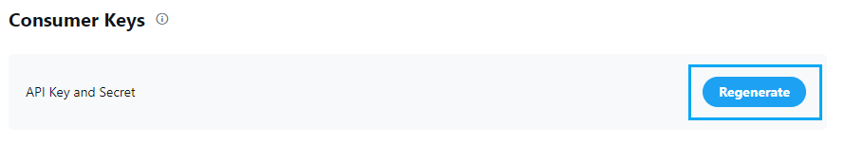

Generate two Authentication tokens as Access Token and Access Secret and save somewhere

Provide the generated 4 keys to Nexelus consultant.

Please note that you cannot regenerate these Keys once provided to Nexelus as it will create new credentials and invalidate the old ones. This means that any integrations that have been setup with prior credentials have to be updated.